(Approx. 1166 words)

A Tour of the Yahoo Finance Website
Part 1 of 2
By Tom Burt, Vice President
Sun City Summerlin Computer Club
https://www.scscc.club
tomburt89134 (at) cox.net

Introduction

Among my various activities for the Computer Club, I moderate the Internet Investing SIG. A key part of those meetings is looking at the financial markets and also individual stocks and funds. My favorite website for doing that is the Yahoo Finance site: https://finance.yahoo.com. I also use Yahoo Finance extensively to track my stock and fund holdings and follow other stocks and funds I'm interested in. This month and next, we'll tour the Yahoo Finance site. There's way too much to cover in a single article.

Yahoo was founded in 1994 and operates as a web portal, search engine, email, and news service. Yahoo has had several owners over time. In May 2021, Verizon sold 90% of its stake in Yahoo to Apollo Global Management, a leading American Investment Management Company. In my opinion, Yahoo Finance is one of Yahoo's true gems.

How to Get Set Up

You can use the Yahoo Finance website for free without a Yahoo account, but you need a free Yahoo account to set up watch lists and portfolios. First, go to http://login.yahoo.com and then choose Create Account. Next, follow the prompts to set up a login ID and password. Once this is done, you will also have a web-based email account on Yahoo.com. This might be handy to use for online shopping.

Once you've signed in to Yahoo.com, you will remain signed in until you explicitly sign out.

Browse to https://finance.yahoo.com, sign in if necessary, and you will see the Yahoo Finance home page (see the screenshot on the next page).

Yahoo Finance Home Page

At the top of the home page is a gray band with links for Finance Home, Watchlists, Portfolios, Cryptocurrencies, Screeners, Yahoo Finance Plus, Markets, News, and others under the "…". Finance Plus is a two-tier premium service. This gray band stays visible at all times.

Hovering over the purple bell at the top right displays a scrollable list of news items. You can also hover over the Mail icon at the top right to display a scrollable list of the Subject lines of recent emails sent to your Yahoo.com email address.

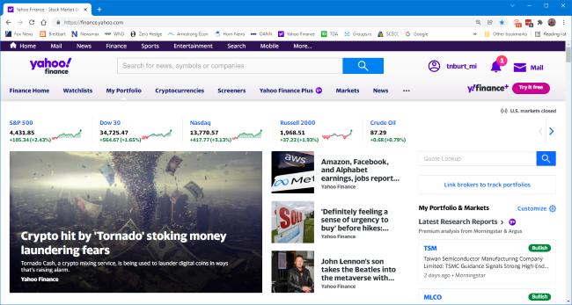

Yahoo Finance Home Page

At the top of the gray band is a search window. You can enter a phrase, company, security name, or security symbol, press the Enter key or click the blue magnifying glass icon. A scrollable list of security symbols and news articles will display. Clicking one of the items in the list will show the security summary screen (if you click on a stock symbol) or the news article.

The home page also displays the current prices of various major indexes and other indicators such as crude oil, gold, and silver prices, the 10-year bond yield, the value of the dollar against various foreign currencies, and the price of Bitcoin. The blue < and > icons let you pan through the indicators.

Below the indicators, the Finance Home page is divided into two panes. The lefthand pane links news items, and the righthand pane displays a customizable set of your portfolios and market summaries. You can scroll down the page to see all of this information.

As with most "free" websites, throughout Yahoo Finance, there are many links to news articles and videos interspersed with "sponsored content" and ads. This content constantly evolves throughout the day.

Data on Stocks, Funds, Currencies, and More

To see extensive details about a specific stock, commodity, or fund, enter that security's name or symbol into the search window, press enter, and then choose the item in the result list for that security. For example, we can enter "Toyota" in the search window and then, in the result list, click the result row with "TM Toyota Motor Corporation." That will display Toyota's financial information summary page (see the screenshot below).

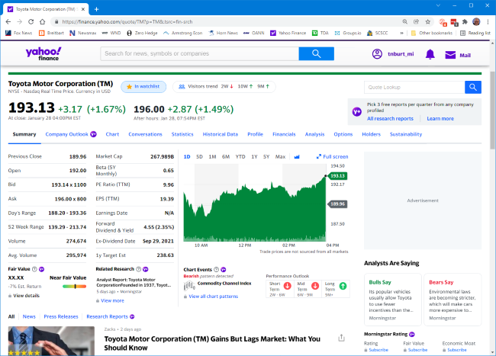

Toyota Summary Page

The scrollable Summary page shows a great deal of information. At the top is the current or closing price, the day's gain or loss compared to the previous day's close, along with the percent gain or loss. Also displayed is the latest after-hours price if the stock trades after the markets close. At the upper left is a panel of trading statistics such as the Previous day's closing price, the Open, Bid, and Ask prices, the day's price range, the 52-week price range, the day's volume of shares traded, and the average daily volume of shares traded.

Also displayed are some key fundamental data such as the Market capitalization, Beta (volatility), Price to earnings (PE) ratio, Earnings per share (for the trailing twelve months), and Forward dividend and yield. There's also a mini chart that, by default, shows the day's price graph. This can be configured for longer time intervals, or you can click the Full-screen option to display the Interactive Chart view (more on this below).

Scrolling down the page shows news articles in the lefthand pane and extensive information about security in the righthand pane.

Above the Summary data is a set of links, including Charts, Conversations, Statistics, Historical Data, Profiles, Financials, Analysis, Options, and Holders. Each of these links displays a page with extensive information. I can't cover all of these in this article, but let's look at the Interactive Chart. You can reach this by clicking the Chart link or the Full-screen icon in the mini-chart. The Interactive Chart page will then display.

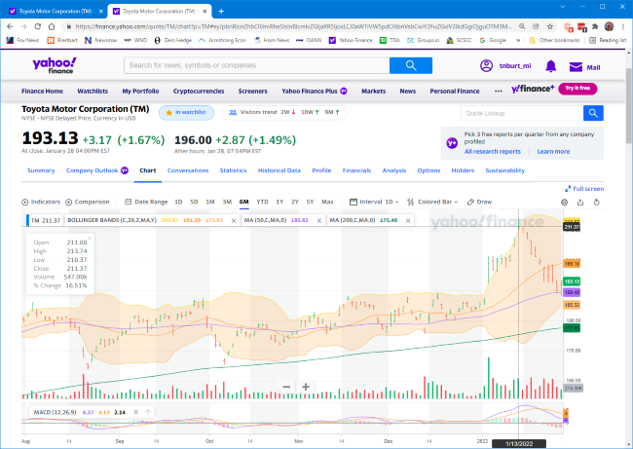

Toyota Interactive Chart (past 6 months)

The Interactive Chart page shows a plot of the daily price of a security over a date/time range. You can choose a predefined date/time range (1 day, 5 days, 1 month, 3 months, 6 months, 1 year, 5 years, or Max), or you can set up a custom date range).

You can choose the format of the price graph (Line, Area, Candle, Hollow Candle, Bar, Colored Bar). In the screenshot, I've selected the Colored bar, which shows the open, high, low, and close and whether the security was up (green) or down (red) on the day.

Along the bottom of the graph are vertical lines indicating daily volume and whether the security was up or down.

Above the graph at the left edge is an Indicators widget which lets you add a variety of technical indicators, such as moving averages, Bollinger bands, a MACD momentum indicator, and many others. Once these indicators are selected and configured, they are displayed on the chart for any security viewed. For example, in the chart shown above, I have the Bollinger bands (20-day moving average bounded by the second standard deviations of that moving average), 50-day moving average (purple), and 200-day moving average (green), and the MACD (a momentum indicator).

Alas, in four pages, we've just scratched the surface of Yahoo Finance's features. In Part 2, we'll look at how to set up Portfolios and Watch Lists and how to set up custom views of those lists.

